**PHYS 4270 / 5390 3.0 - Astronomical Techniques Fall-Term Project - Part 1/3**

**I. Processing and Analyzing CCD Data**

**Due: (upload in PDF by) 22:00 Monday 2 November 2020**

1. **Introduction**

The major fall-term project consists of two separate, but related, assignments:

* 1. This first assignment provides practice with reducing and analyzing CCD frames (or images) using already acquired data (provided by the instructor) which is worth 1/3 (undergrads) or 1/2 (grads) of the fall-term project.
  2. The second assignment (which will be divided into two parts) involves acquiring data using the York Observatory’s 1 m Telescope and STXL 6303E CCD camera, as well as reducing, analyzing and interpreting these data, which is worth the remainder of the grade.

All assignments, including this one, are available from the course website.

To undertake these assignments, the student is expected to be familiar with Chapter 2 on Detectors/CCDs and CCD data reduction and have a basic facility with IRAF, the image reduction and analysis software used in this course on the linux machine *cosmos.sci.yorku.ca* .

On the course website, students will have access to a number of calibration frames – bias and flat-field frames – as well raw science frames, all in FITS format. (No dark frames were acquired or required since the CCD camera and electronics were cryogenically cooled.) These data were taken for the instructor at the Newtonian focus of the 1.8 m Plaskett Telescope at the Dominion Astrophysical Observatory in Victoria, B.C. in 2014 under photometric conditions. (These data may be accessed via the Canadian Astronomy Data Centre, the [DAO Science Archive](https://www.cadc-ccda.hia-iha.nrc-cnrc.gc.ca/en/dao/).)

1. **Building the Calibration Images**

Before raw CCD science frames can be analyzed, they must be pre-processed; that is, the bias level and dark signal must be subtracted, and the pixel-to-pixel quantum efficiency variations must be removed through the division of a normalized, high signal-to-noise ratio flat field. The science frames in this case are *g’*, *r’* and *i’* (i.e., SDSS) filter frames of the standard star field, Wolf 1346. Undergrads, see Table 1 for which filter set you are to reduce – “your filter set”; grads are required to reduce and analyze data for all three filters.

Table 1 - Filter to Reduce (undergrads)

|  |  |
| --- | --- |
| Last digit of Student Number | Filter to Reduce |
| 0, 1, 2 | *g’* |
| 3, 4, 5, 6 | *r’* |
| 7, 8, 9 | *i’* |

The following steps are required to “pre-process” these data:

* 1. Download the bias frames, “your” flat-field and science frames to the relevant (cosmos or local) directory from the *calibration* folder of the course website. (The calibration frames are each in a single zip file.)
  2. Become familiar with the basic FITS header information, provided on the course website and discussed in class. From within the IRAF environment[1], run IMHEADER, i.e.,

imhead l+ flat*.fits [ > flat_info]

where “l+” indicates “show the entire or **l**ong header” and text in [ ] is optional. (In this case the “>” indicates redirection of the output from the screen to the text file, “flat_info”.)

* 1. Run the IMSTATISTICS routine on all the bias frames, saving the results to a file; e.g.,

imstat bias*.fits [ > bias.stats]

Inspect the *mean* and *stddev* columns to ensure there are no discrepant frames. (What constitutes “discrepant” needs to be decided in advance. So long as the *stddev*s are similar, and the *mean*s are not significantly different, it is unreasonable to reject any frame.) It is always a good idea to DISPLAY one or more of the bias frames in ds9 to get a feel for what a bias frame looks like. If there is a discrepant frame, be sure not to use it when building the *average* bias frame. You must, however, explicitly provide a rationale for not including any calibration frame in the write-up for this or any other assignment (see Section 4). A note on DISPLAYing data. The format of the DAO data are all 1020 × 2350. IRAF’s default display expects 512 × 512 frames. Thus, before displaying any frame in this assignment, be sure to issue the following command which resets the expected display format:

set stdimage=imt2048

(It is always important to take a more detailed look at your calibration and science frames. In particular, examine various parts of a frame via one-dimensional plots. To do this, use the utility IMPLOT. For example:

implot bias01.fits

You will see the signal (ADU) as a function of column number of the frame “bias01.fits” (for example) displayed in a separate graphics window. You may have to click on the top of the graphics to activate it. By default, the line chosen is the central line. Suppose you wish to see a plot along **c**olumn 145. Type “:c 145” in the graphics window and voila, column 145 is displayed. Suppose you wish to exam the *average* of **l**ines 892 to 992.

Type “:l 892 992”. Or type “?” for help. There are a great many options. When you are finished, type “q” to quit the graphics window and return to the xgterm window.)

To ensure the entire frame is displayed, click on the “Zoom” option in the top ds9 menu and select Zoom to Fit Frame. Remember, astronomers usually prefer an inverted black-and-white frame. (The eye is more sensitive to faint features with this mapping.) Click on the “Color” option in the top ds9 menu and be sure the “Invert Colormap” is selected. You should only print frames using the inverted color map. By the way, the top right window showing the magnified area around the cursor can be very helpful later on.)

1. Build the *average* bias frame using IMCOMBINE. A straight averaging of all “good” bias frames is normally sufficient; for example,

imcombine bias*.fits average_bias.fits combine=average

IRAF allows a way of handling a repetitive operation on a number of files. First, create a file containing the names of the relevant files, one name per row. For instance, one can use a unix/linux utility to generate this file at once via:

ls -1 bias*.fits > bias.list

One can then invoke IMCOMBINE in the following way to generate the *average* bias frame: imcombine @bias.list average_bias.fits combine=average

Note the use of the “@” to denote a filename. Either way, take a look at “average_bias.fits” to ensure it appears reasonable with no discrepant values.

1. Subtract the *average* bias frame from all flat-field frames; for example, imarith @flat.list - average_bias.fits [b//@flat.list](mailto:b//@flat.list)

Notice the construction b//@flat.list; this prepends the letter “b” onto all the file-names listed sequentially in “flat.list.” Very handy to keep in mind. You are free, of course, to name processed files any way you wish. Note well (using IMPLOT) that the flats are not entirely flat, but drop off significantly towards the top of the chip.

1. Use IMSTATISTICS to investigate the bias-subtracted flat fields. Normally, a series of flats will have similar averages, but in this series, because it involves twilight (sky) flats (i.e., flats taken during astronomical twilight), the *mean*s are significantly different. (If you DISPLAY the individual flats, you will see some star frames on a bright background: remember, these flats were taken during morning twilight. The key, however, is that the telescope was not tracking during the exposures and so the stars are in different locations in each exposure, something entirely acceptable so long as you handle the combining correctly.) The flats can still be combined, but not using simple averaging as for the biases. In this situation, perhaps the most complicated of all, the following incantation of IMCOMBINE is appropriate:

imcombine @fixedflats.list final_flat.fits combine=median reject=avsigclip scale=mode weight=mode

This requires some explanation. First, the files are scaled before being combined and they are weighted by their *modes*. Next, a distribution of intensities for each pixel, (x,y), is formed and

the median of the distribution is assigned the value for pixel (x,y). Actually, the avsigclip requirement first filters this distribution, removing pixels more than (say) 3-standard deviations from the *mean*, an efficient way of removing discrepant pixels. This type of filtering is useful, providing at least several frames are being combined (as in this case).

1. Normalize the combined flat field, i.e., scale the flat field so that it has an *average* of exactly 1. For example, run IMSTATISTICS on final_flat.fits, then divide this frame by the *mean*, e.g.,

imarith final_flat.fits / “mean” nfinal_flat.fits

where “mean” is the actual numerical value of the *mean* of final_flat.fits and “nfinal_flat.fits” is the normalized flat field. Be sure to use IMSTATISTICS on nfinal_flat.fits to be sure this worked.

1. Subtract the *mean* bias from your science frame(s) and then divide this frame by the normalized flat field (of the appropriate filter). The science data are now ready to be analyzed.
2. **Data Analysis**

Figure 1 shows a raw *r’* filter image (or frame) of the field containing the photometric standard star Wolf 1346 (encircled, hereafter referred to as ‘W’) with N up and E to the left (the standard astronomical orientation). A brighter, nearby star labelled ‘H’ (with coordinates provided in the figure caption), HD 340612, is also displayed.

(NB: when you first DISPLAY this image, you will *not* see it in this N/E orientation. Once you have fully reduced the relevant image(s), you will likely find it helpful to use the IRAF utility ROTATE to put it into this preferred orientation for analysis. For example if you wanted to rotate the file “abc.fits” by 45 degrees clockwise, then:

rotate abc.fits abc_rotated.fits -45 )

The following describes the steps for reducing and analyzing these data (for a given filter):

* 1. Construct the calibration images as above, and correct the relevant science frame(s). DISPLAY the final reduced image using ds9 to ensure it looks like that in Figure 1.
  2. Using IMEXAMINE with the “m” option, record the *mean* and standard deviation of the sky background for at least four well-separated, blank areas, but not near the edges of the frame (and certainly not the “curved background”). (The “m” option computes the *mean* and standard deviation of a 5 pixel × 5 pixel box centred on the cursor.) Using the “,” option of IMEXAMINE, find and record the centroids of stars W and H, as well as the full-width at half maximum (FWHM) of both stars. (“Centroid” refers to the intensity-weighted (x,y) centre of the star image, and the FWHM is a measure of the image quality and tracking quality.)
  3. Using the centroids of stars W and H and the data Figure 1 and its caption, find the pixel scale (arcseconds/pixel) of the image (grads: for each filter).
  4. Find the position angle of the (rotated) image; i.e., the angle between the “up/down” CCD axis and the Right Ascension axis (grads: only for *r’* data).
  5. Using position data for star W, the pixel scale from #3, and the centroid of star Q in pixels, find the J2000 coordinates – Right Ascension and Declination – of star Q (grads: for all filters).
  6. Perform a curve-of-growth analysis on one reasonably bright, non-saturated, fairly isolated star using the QPHOT utility. Before running this routine, it is necessary to create a text file containing a single record with the (x,y) centroid of the star, e.g., “starz.txt”**.** If will also be necessary to estimate a reasonable location for the radius of the sky annulus as well as the width of the sky annulus. Then one might (for example) use the following to generate a curve-of-growth analysis (though you will need to experiment with the parameters): first type “DIGIPHOT” followed by “APPHOT” which are two photometric packages in IRAF. Then:

qphot *abc* cbox=5 annulus=25 dannulus=5 aperture=5,10,15,17,19,21,23,25 coords=starz inter-

where “abc” refers to the image’s name, “cbox” is a centring parameter that the utility uses to identify the star’s centroid, “annulus” and “dannulus” are self-explanatory, “aperture” is a list of aperture radii in pixels, “coords” is the name of the text file with the estimate of the star’s centroid, and “inter-” indicates this is not to be done interactively. The result of the analysis is recorded in the file (for example) “abc.mag.1”. Be sure to experiment with the various parameters. State and justify the optimal aperture radius to use (arcseconds), the asymptotic instrumental magnitude of the star, and the aperture correction based on this single star.

(It is important to be familiar with the output from a “mag” file. Following the entire preamble, which includes a variety of parameters including the sky aperture, object centroid, background level, etc., the aperture photometry data are reported in a table at the end of this file.

* + - Column 1 is the aperture radius (pixels) centred on the centroid position,
    - Column 2 is the total signal within this radius,
    - Column 3 is the total number of pixels in the aperture,
    - Column 4 is the total signal in the aperture minus the background,
    - Column 5 is IRAF’s instrumental magnitude (which is the “true” instrumental magnitude

+ 25) and

* + - Column 6 is the formal uncertainty in magnitudes.

**Note**: Compute the “true” instrumental magnitude for the star(s) using information from column 4 and do *not* rely on IRAF’s magnitudes that include an additive constant. IRAF’s magnitudes are perfectly fine, however, for assessing aperture corrections, optimal apertures, etc.)

* 1. Using the reduced data:

1. Undergrads: For 25 other non-saturated, non-blended, non-saturated stars in the science frame, find the (x,y) centroids of their positions, measure their FWHM (pixel and

arcseconds), measure their instrumental magnitudes and compute their apparent magnitudes and report these in a table. (Hint: Recall that the apparent magnitude for a given filter, *m* is related to its “true” instrumental magnitude for that filter, *m*inst via: *m* = *m*inst + *C* where *C* is a photometric constant. As well, the instrumental magnitude *m*inst

= -2.5 log10(total counts/second) . Comment on the photometric constants, instrumental magnitudes and apparent magnitudes for each star.

1. Grads: Do the same thing as in (a), but for the same stars in all 3 filters. Additionally in the table, include columns with the colours, *g’-r’* and *r’-i’* of each of the stars using the information in Table 2.

Table 2 - SDSS Magnitudes for Wolf 1346

|  |  |  |
| --- | --- | --- |
| *r’* | *g’-r’* | *r’-i’* |
| 11.75 | -0.35 | -0.31 |

* 1. Find the surface brightness of the sky background in your science frame(s) (magnitudes/arcsec***2***). (Hint: Using the pixel scale determined above, convert the *mean* sky level from counts/second/pixel to counts/second/arcsecond***2*** and convert to magnitudes as above.) (Grads must compute the surface brightness in all three filters.)

1. **Write-Up**

The write-up for this assignment should be reasonably short. It should contain a title page with your name and student number clearly indicated. No introduction or conclusion is required. The report should include:

* A basic description of building the calibration images, including the statistics for the biases and flats, whether any images were rejected (and why), as well as the names of your (final) *average* bias and normalized flat field. It is useful to describe briefly the nature of the biases and flats (e.g., areas with cosmetic blemishes, bad columns, etc.)
* A description and answers (where appropriate) for each of the 8 items in “Data Analysis” with supporting details. Be sure to include a printed copy of your reduced frame (on an inverted colour map), and provide the table summarizing the photometry for each of the 25 stars (grads: for each filter).
* The (hard copy) report should be uploaded to the course webpage by 10 pm on Thursday 29 October 2020.
* I need not mention that while it is acceptable to consult with a colleague or employ resources beyond this course (and attributed when appropriate), the uploaded document must reflect your efforts alone.

1. **Rubric**

The marking scheme for this part of the Fall Term Project will be as follows:

|  |  |  |
| --- | --- | --- |
| **Item** | **Weighting**  **(undergrads)** | **Weighting**  **(grads)** |
| Calibration Process:  Note your filter, inspect and build biases, construct and normalize flat fields, possible rejection of data, pre-processing  data (*with comments*). | 10 | 10 |
| Data Analysis:  Complete all 8 steps for “your filter.” Measure sky background, assess quality of data (FWHM of a set of isolated stars in pixels and arcseconds), compute the focal-plane scale, frame orientation, generate instrumental, asymptotic, and apparent magnitudes, photometric constants, and sky surface  brightness. Uncertainties where necessary. | 20 | 35 |
| Quality of Presentation:  Thorough, neat, logical, *inverse* colour map image(s), scale of images, cardinal directions and scale on images, showing representative calculations | 10 | 10 |
| **Total marks** | **40** | **55** |

Figure 1: Raw *r’* image of photometric standard star (encircled) Wolf 1346 from the Dominion Astrophysical Observatory (Plaskett 1.8 m Telescope). The star marked ‘H’ is the nearby star HD 340612 [α(2000): 20h 34m 13.7s, δ(2000): +25 06’ 30”]

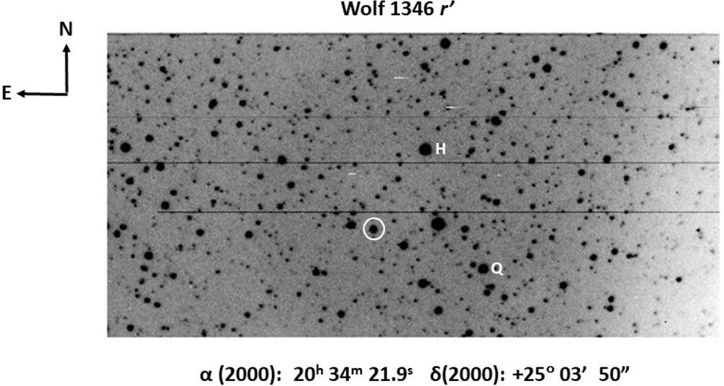

1. In order to encourage experimentation and foster a deeper understanding of the underlying utilities, instructions are given for the command-line driven version of IRAF. The full commands are given explicitly herein because some students may not have had sufficient experience using IRAF.